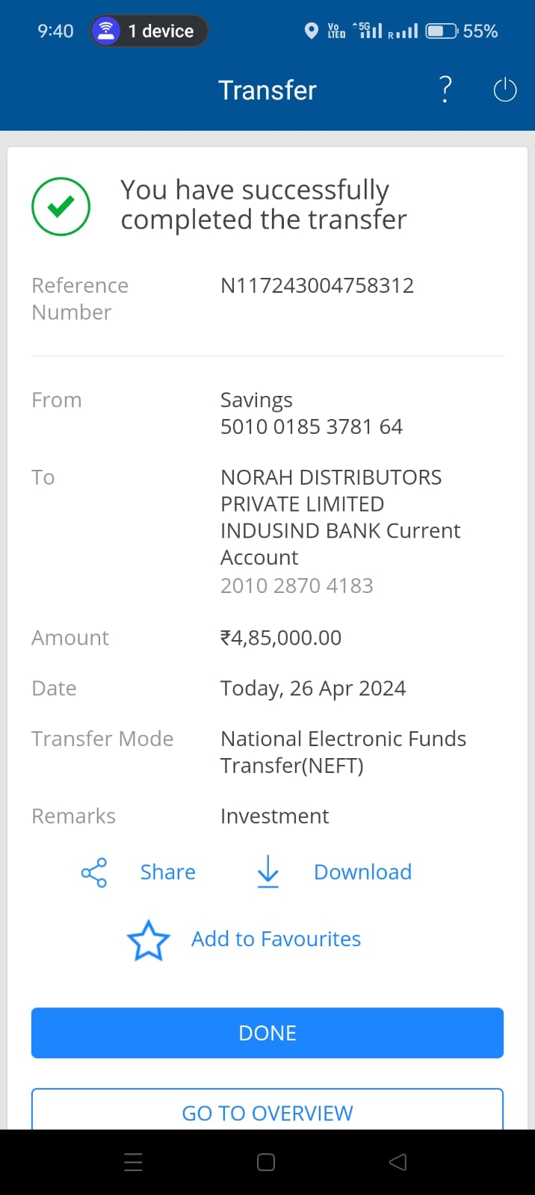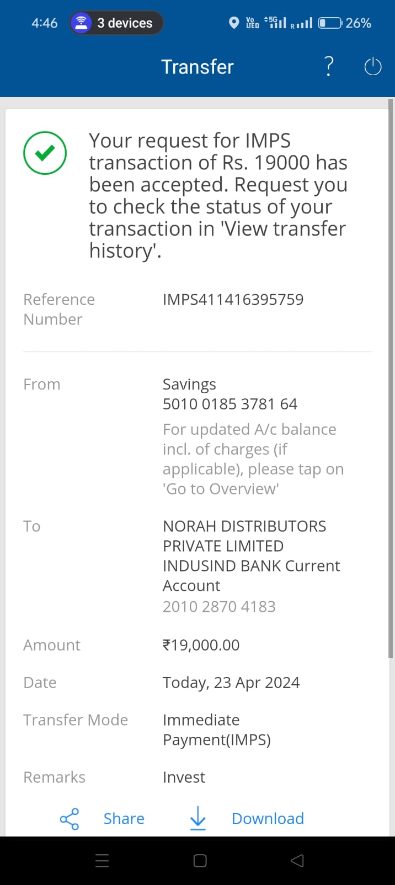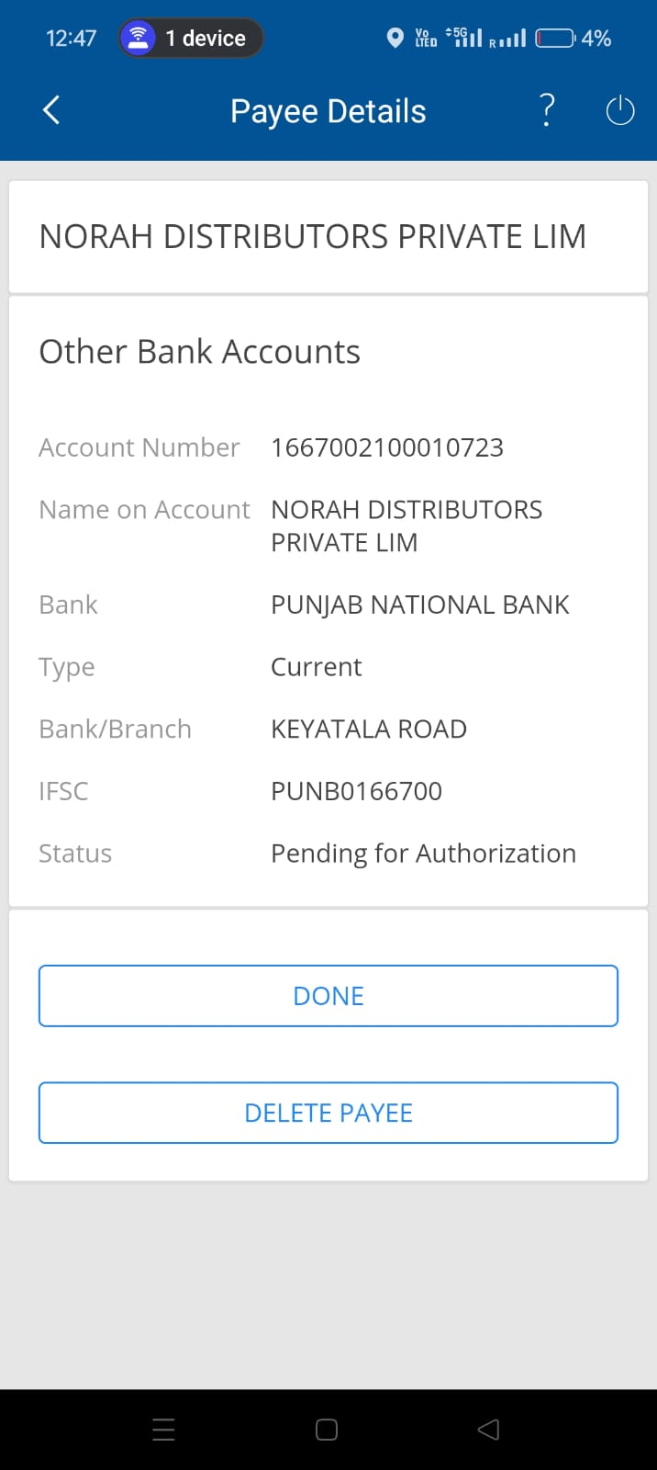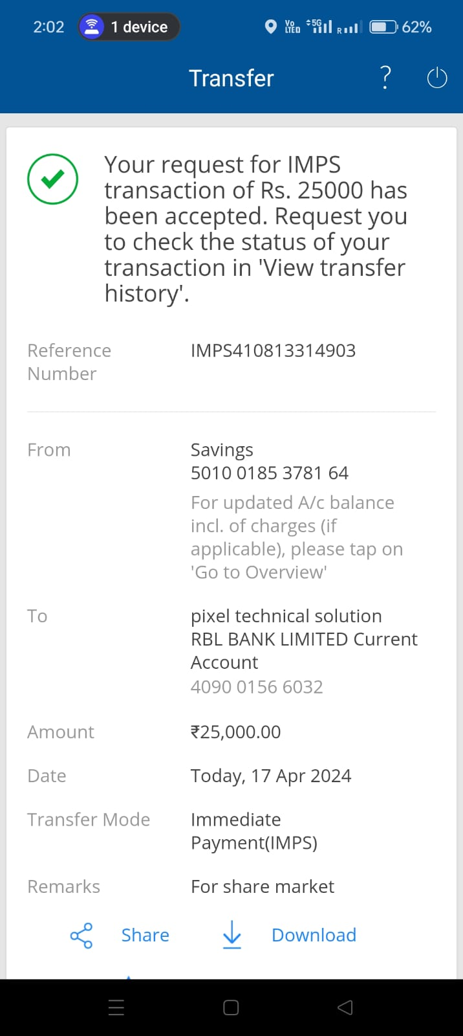
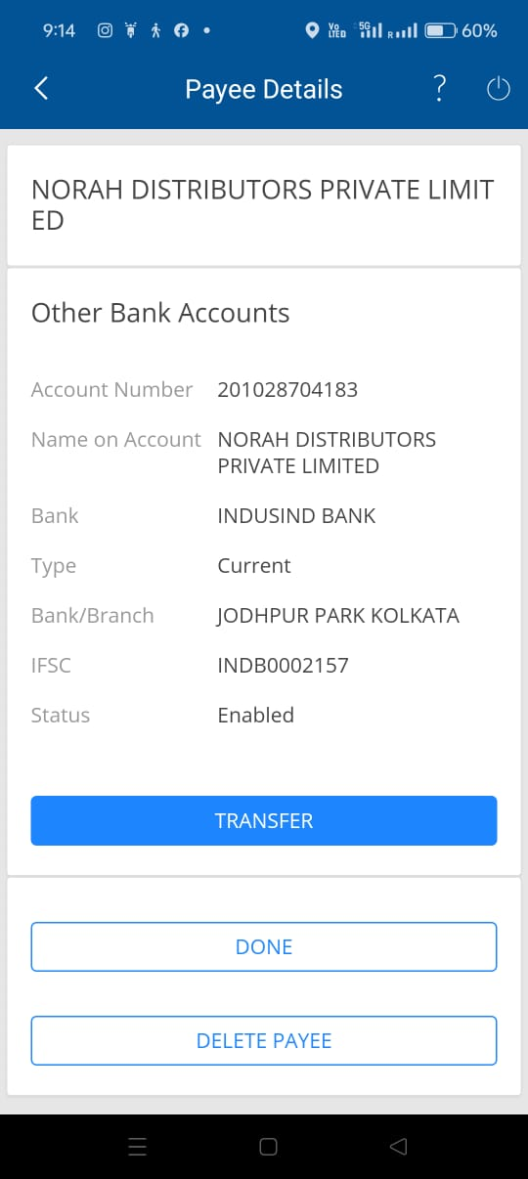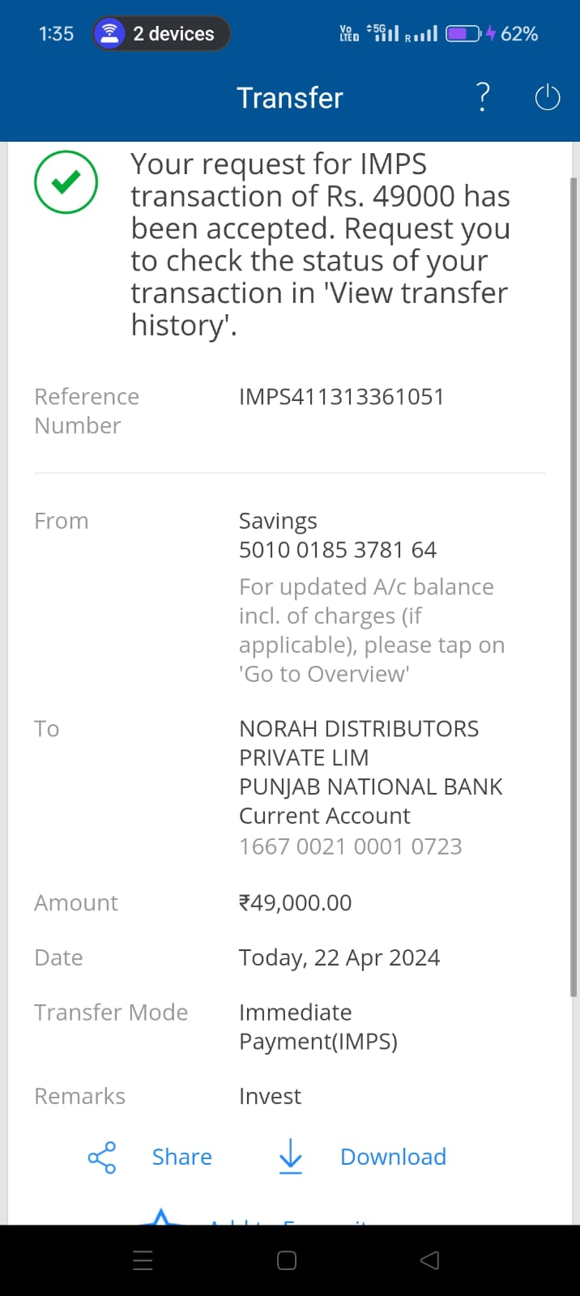
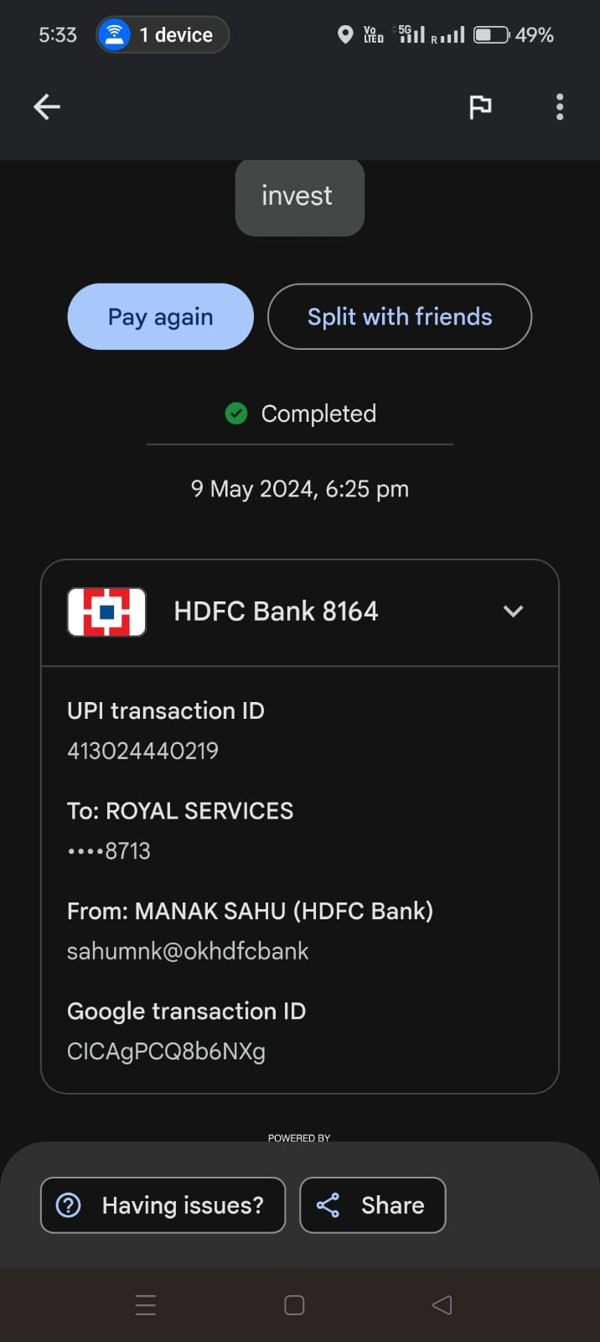

Latest account details:
Bank - Bandhan Bank Limited
Name- SANSAR TRADER
Account No - 20100009368441
Acount type - corporate account
IFSC -BDBL0001593
State - MAHARASHTRA
Branch - HANDARKAR ROAD

URL: https://win.inegindia.com/pages/stock/home

